

Practices for Secure Software Report

Table of Contents
Document Revision History 3
Client 3
Instructions 3
Developer 4
1. Algorithm Cipher 4
2. Certificate Generation 4
3. Deploy Cipher 4
4. Secure Communications 4
5. Secondary Testing 4
6. Functional Testing 4
7. Summary 4
8. Industry Standard Best Practices 4

Document Revision History

Version | Date | Author | Comments
1.0 | 2/22/2026 | Corwin Nunes

Client



Developer
Corwin Nunes

Algorithm Cipher

Artemis Financial requires a reliable method to verify that data transmitted through its web application has not been altered in transit. A checksum-style integrity mechanism using the SHA-256 hash function (from the SHA-2 family) is well suited for this purpose. SHA-256 generates a fixed-length 256-bit (32-byte) digest from input data, and even a single-character change produces a dramatically different digest. This makes the hash an effective tamper-evident fingerprint for files and API responses.

Cryptographic hash functions are one-way algorithms, meaning the original data cannot feasibly be reconstructed from the digest. For integrity verification, the most important properties are preimage resistance, second-preimage resistance, and collision resistance. With a 256-bit output, SHA-256 provides a strong security margin against collisions, especially when compared to older algorithms such as MD5 (128-bit) and SHA-1 (160-bit), both of which have known collision vulnerabilities and are no longer recommended for security-sensitive use.

While SHA-256 itself does not use encryption keys, it integrates naturally into a secure communications architecture. In HTTPS (TLS), the server authenticates using an asymmetric certificate and key pair, after which a symmetric session key is negotiated for efficient data transfer. Hash functions like SHA-256 play a critical role in these protocols by supporting message integrity and validation. If Artemis Financial later requires authentication in addition to integrity, the checksum mechanism can be extended using HMAC-SHA-256 or a digital signature applied to the hash.

Given its strong security properties, widespread industry adoption, and full support within the Java ecosystem, SHA-256 is an appropriate and maintainable choice for ensuring data integrity in this project.

Certificate Generation

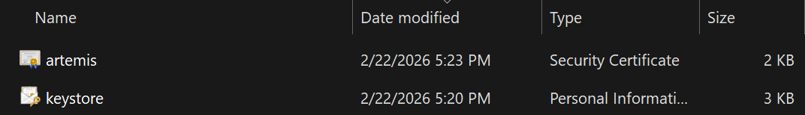
Self-signed SSL certificate successfully generated using Java Keytool and stored in the application keystore.

Deploy Cipher

Spring Boot application configured to use the SSL keystore and successfully started with HTTPS enabled on port 8443.

Secure Communications

Web browser confirming a secure HTTPS connection to the application using TLS encryption

Secondary Testing

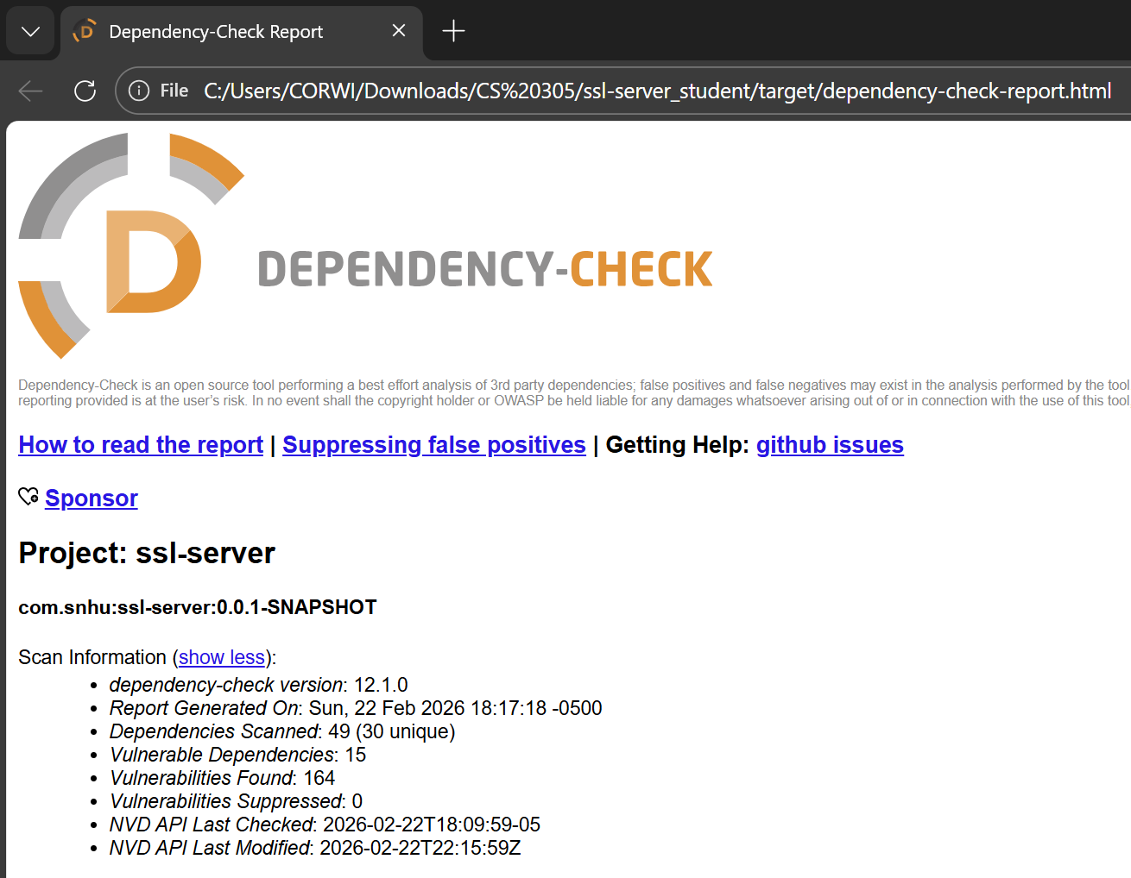
OWASP Dependency-Check executed to identify known vulnerabilities in third-party dependencies used by the application.

Functional Testing

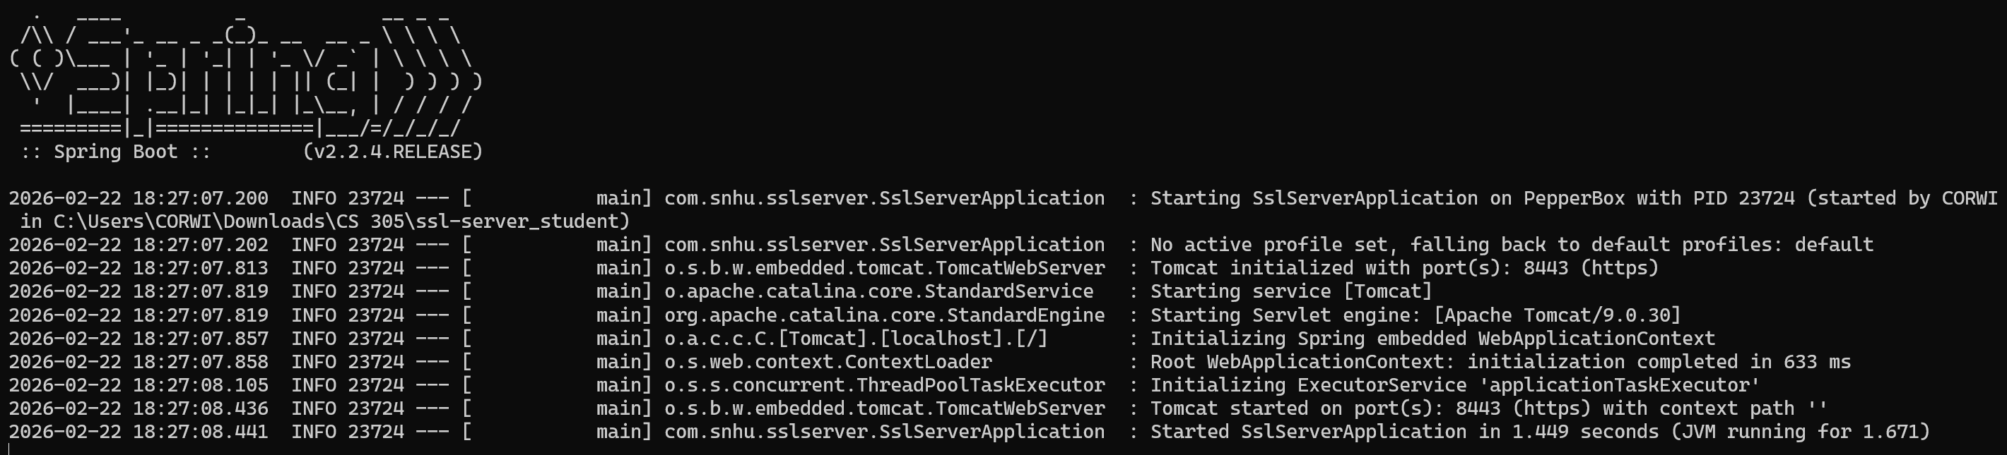
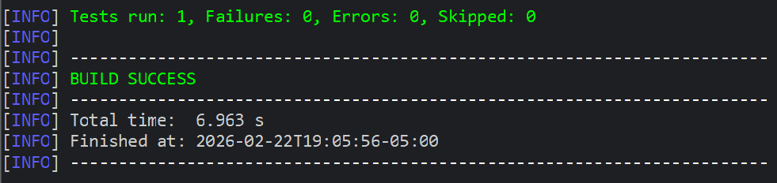
Refactored application executed successfully without runtime errors, confirming functional integrity after security enhancements.

Summary

This project improved the security of the Artemis Financial web application by implementing a SHA-256 checksum to verify data integrity and configuring HTTPS with TLS to protect data in transit. The application was refactored to support secure communication using a trusted certificate, and functionality was validated through successful application execution and browser-based verification of encrypted connections. Additional testing with OWASP Dependency-Check was performed to identify known vulnerabilities in third-party libraries. These updates collectively strengthen the application’s ability to detect tampering, protect sensitive data, and operate securely.

Industry Standard Best Practices

In financial applications, protecting data integrity and confidentiality is critical because even small changes to transmitted data can result in financial loss or loss of trust. Using SHA-256 provides a strong, collision-resistant method for detecting tampering, which aligns with modern cryptographic standards and avoids weaknesses found in older algorithms such as MD5 and SHA-1. Enforcing HTTPS with TLS ensures that sensitive financial data is encrypted and that clients can verify the server’s identity before transmitting information. Regular dependency vulnerability scanning reflects industry expectations for managing third-party risk and maintaining secure software over time. Together, these practices help reduce attack surfaces, support regulatory expectations, and reinforce customer confidence in the system.

